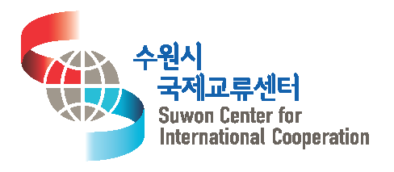
Application Form for Korean Class
(申込書,申请书)
Name  (氏名, 姓名) |  | (Korean) | Nationality  (国籍, 出生地)
 |  | (English) | Gender  (性別) | M, F
 |  | (Chinese) ※ If there is Chinese | Date of Birth  (生年月日, 出生日期) | . .
Occupation  (職業, 住址) |  | ※ write your workplace / School etc
Class  (受講講座, 申请课程) |  | □ Korean Beginner □ Korean Elementary □ Intermediate
Contact  (連絡先,  联系  方式) | Address  (住所, 住址) | Postcode( - )
Cellphone
(携帯, 手机号)
 | E-mail
Foreign Language Skills  (外国語能力, 外语能力) |  | Languages you can speak  (可能な外国語、应用外国语) |  | Level  (レベル, 外语水平)
 |  | ※ Please write languages you can speak |  | □ Fluent(native)  □ high □ inter □ low
 |  | ※ Please write languages you can speak |  | □ Fluent(Native)  □ high □ inter □ low
Buddy Matching  Program  (韓国人チューター, 互相帮助的朋友) |  | SWCIC Korean Class offers students opportunities of supplementary study and conversational practice through a buddy matching with a Korean college student.  Please check the below options  □ Want a Buddy Matching □ Do not want a Buddy Matching  ※ Choose the time you wish to meet your Korean Buddy.  □ Week days(Afternoon to evening) □ Weekends(Sat, Sun) □ Any time is O.K  □ Others( ※ Please write when : )
Comment  (特記事項, 其他事项) |  | ※ Please write a kind of Korean cultural experience that you want to do with your Korean Buddy.
I apply for Korean Class at Suwon Center for International Cooperation as above.
上記のように、 (財)水原市国際交流センターの韓国語教室に申し込みます。
特此申请以上水原市国际交流中心韩国语课堂的韩语课程。

Date: . .
Name of applicant(志願者, 申请者) : (Sign,署名,签名)

