SWCIC Korean Culture Day
<Suwon City Tour Bus>
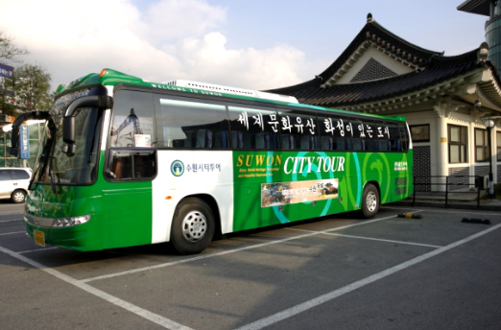

SWCIC Korean Culture Day April Event
When |  | April 23(sat) from 13:00~17:30
Where |  | Suwon City Tour Center (Suwon Station exit number 4)  (Meeting point)
What |  | Ride on Suwon city tour bus and enjoy various cultural inheritances in Suwon vividly with foreign friends from various countries
Qualification |  | Any foreigners who live in Suwon or study in university located in Suwon 29 People.(first come first served)
Price |  | Free
Itinerary |  | Time Place Contents  13:00~ 14:00 Suwon Station exit number 4 Orientation & Ice breaking  14:00~17:00 (approximately) Suwon city tour bus (Haewoojae - Hwaseo gate - Hwaseong Fortress - Jangan gate - Hwahong gate - Yeonmudae - Suwon Hwaseong Museum) Enjoy various landmarks in Suwon. historical explanation about Suwon see traditional martial art performance and experience Korean Archery (Guk-gung)  ~17:30 Suwon city tour center Farewell
How to apply? | Application period | March 29th ~ April 15th
 | Apply & questions | Send an e-mail to "scvakorea@gmail.com"
 |  | Please fill your information in application form.
Remarks |  | We don't offer any transportation.
 |  | Please come to the Suwon city tour center (Suwon station exit number 4) on time.

Where we’re going?
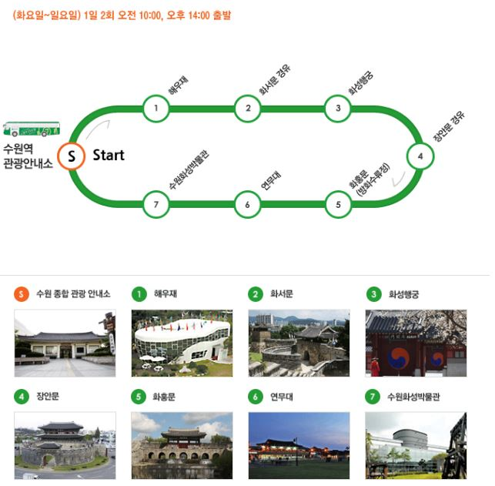

Hello, everyone!

This is the first event organized by SWCIC this year.

You may know that Suwon has a lot of cultural heritages. Have you ever been there? Were you unable to understand historical meanings in detail because of language problems? Then, you have the chance to enjoy Suwon city bus tour program with SWCIC.

For those participants, all tour fees are funded by SWCIC. Start with Haewoojae, very unique toilet shaped building, we will visit various cultural-historical sites along with Hwaseong Fortress. See decent scenery with your eyes. You may see Korean historical martial performance and experience Korean Archery, too!

We are looking forward to seeing you and become friends with you. SWCIC is always open for you. Do not hesitate to contact us. you can find additional information at http://www.Suwoncitytour.co.kr/.

Matters need attentions

Only those who live in Suwon or study in universities located in Suwon are qualified to join.
Application should be received in advance. Only limited seats are available, so please contact us if you are not able to participate in program after application for participation.

